**RECEPTION Reading Challenge**

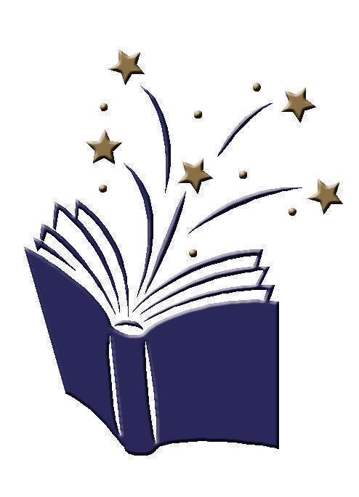**Going for Gold Reading Challenge**

I have chosen my own book and told an adult why I chose it.

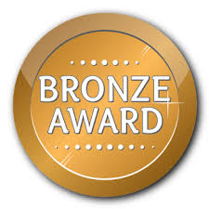

I have read a

book by

I have joined in with a

book that rhymes.

I have listened to and joined in with a traditional tale e.g. The Three Little Pigs.

I have shared a book with an adult 5 days in a row and recorded this on Seesaw.





I have shared a book with an adult 7 days in a row and recorded this on Seesaw.

I have shared a non-fiction book with an adult and learnt a fact.

I have learnt a new word and told the meaning to my class.

I have drawn a picture of two characters from a book and labelled them with their names.

I have told an adult what I think will happen next in a book.

I have read two books

by the same author.

I have shared a book with an adult 10 days in a row and recorded this on Seesaw.