**Year 2 Reading Challenge**

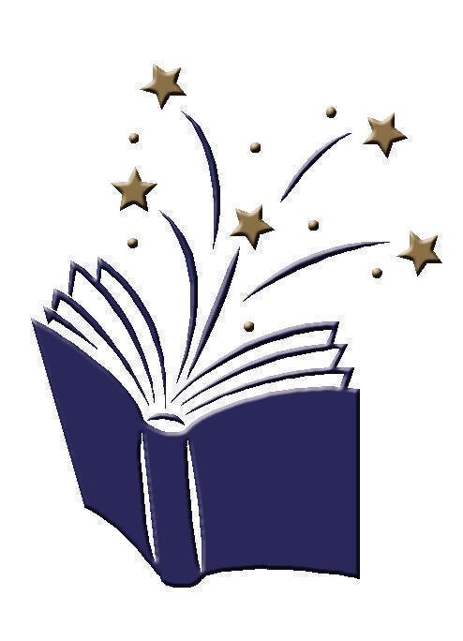**Going for Gold Reading Challenge**

I have made a prediction from looking at the front cover of a book.

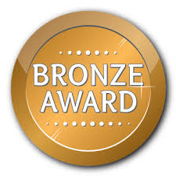

I have drawn a story map for a story that I have read.

I have read a non-fiction book and shared a fact with the class.

I have written a book review to share with the class

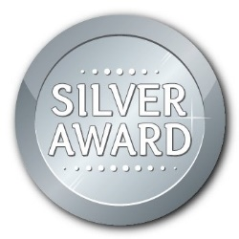

I have shared a book with an adult 10 days in a row and recorded this on Seesaw.



I have recommended a book to a friends and told them why I enjoyed it.

I have shared a book with an adult 15 days in a row and recorded this on Seesaw.

I have read a book about something I am interested in e.g. dinosaurs.

I have read a magazine or a comic.

I have read a set of instructions.

I have read two books

by the same author.

I have shared a book with an adult 20 days in a row and recorded this on Seesaw.