**Year 3 Reading Challenge**

**Going for Gold Reading Challenge**

I have read a magazine or a comic.

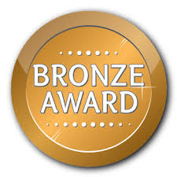

I have found out facts about an author I know.

I can explain to an adult how a character is feeling and why.

I have read a non-fiction book and written down 4 facts I found interesting.

I have read for 15 mins 10 days in a row and recorded this on Seesaw.





I have read a book by Roald Dahl.

I have read for 15 mins 15 days in a row and recorded this on Seesaw.

I have read a book that has won an award.

I can make comparisons between two books I have read.

I have written a book review for a book I have enjoyed.

I have read two books

by the same author.

I have read for 15 mins 20 days in a row and recorded this on Seesaw.