**Year 5 Reading Challenge**

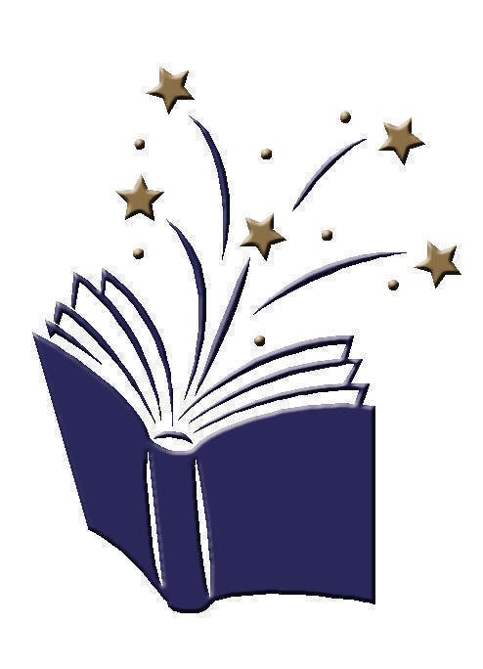**Going for Gold Reading Challenge**

I have read a sequel to a book I have already read.

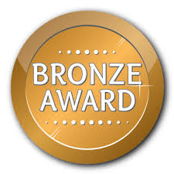

I have read a book which was a trusted adult’s favourite as a child.

I have researched an author

and presented my work.

I have used a non-fiction book for research to answer three questions I wrote.

I have read for 15 mins 10 days in a row and recorded this on Seesaw.

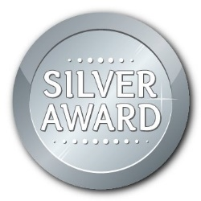



I have read a book by an author recommended to me by my teacher.

I have read for 15 mins 15 days in a row and recorded this on Seesaw.

I have read a biography or autobiography.

I have written a book review for a book I have enjoyed.

I have read a poem, learnt it and performed it to an audience.

I have read two books

by the same author.

I have read for 15 mins 20 days in a row and recorded this on Seesaw.