**Year 6 Reading Challenge**

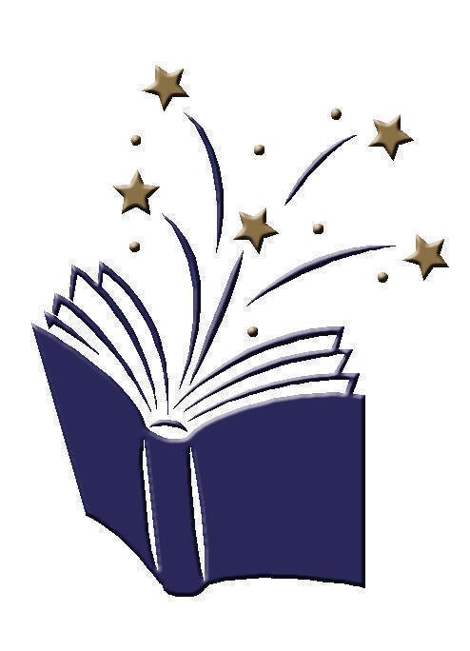**Going for Gold Reading Challenge**

I have read a sequel to a book I have already read.

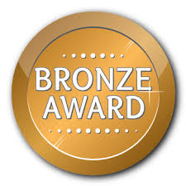

I have read a book that was made into a film and compared the two.

I have researched an author

and presented my work.

I have read a book that was written before my grandparents were born.

I have read for 15 mins 10 days in a row and recorded this on Seesaw.

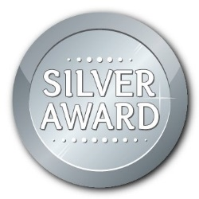



I have read a book by an author recommended to me by my teacher.

I have read for 15 mins 15 days in a row and recorded this on Seesaw.

I have read a book about a topic I have learnt about in school.

I have written a book review for a book I have enjoyed.

I have read a poem, learnt it and performed it to an audience.

I have read a book where the main character is different from me.

I have read for 15 mins 20 days in a row and recorded this on Seesaw.