**Year 1 Reading Challenge**

**Going for Gold Reading Challenge**

I have chosen my own book and told an adult why I chose it.

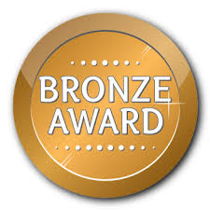

I have read a

book by Lauren Child

I have read a book

about animals.

I have read or listened to a non-fiction book.

I read for 10 minutes to an adult, 5 nights in a row.

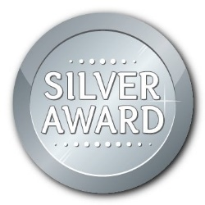



I have read a book for 10 minutes, every day in a row for 10 days.

I have looked at a front cover from a book and made a prediction from it.

I have written a book review to share with the class.

I have described ow a character is feeling in a story and why they are feeling like that.

I have told my teacher about a book I have read at home and why I enjoyed it.

I have read a poem.

I have read a book for 10 minutes every day in a row for 15 days.