**Year 4 Reading Challenge**

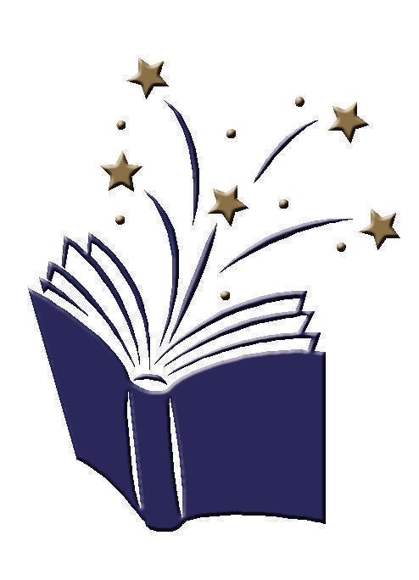**Going for Gold Reading Challenge**

I have read a book that has won an award.

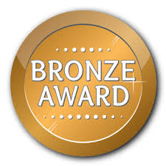

I have compared two characters from two different books I have read.

I have researched an author and presented my work.

I have read a non-fiction book and created a poster of facts I have learnt.

I have read for 15 mins 10 days in a row and recorded this on Seesaw.

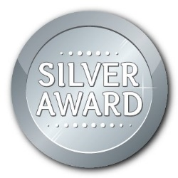



I have read a book by an author recommended to me by my teacher.

I have read for 15 mins 15 days in a row and recorded this on Seesaw.

I have read a book that is set in a different country.

I have read a poem and performed it to an audience.

I have written a book review for a book I have enjoyed.

I have read two books

by the same author.

I have read for 15 mins 20 days in a row and recorded this on Seesaw.